Section 1: Complete this section once the RPL evidence has been reviewed.

APPLICANT DETAILS

First name:
Surname:

UNITS OF COMPETENCY

Unit code | Unit title
CUAPPR201 | Make simple creative work

RPL OUTCOME
Competent (C)
Not yet competent (NYC)

ASSESSOR DETAILS

Assessor name:
Date assessed:

Section 2: Mapping the Evidence
In the table below, place ticks against the assessment instruments that were used as part of the RPL assessment:
☐ | Portfolio
☐ | Competency Discussion
☐ | Observation Task

In the table below, use ticks to indicate which instrument/s were used to successfully collect evidence for a competency standard. Do not place a tick if the evidence collected was deemed not yet satisfactory.

For example, if a candidate is assessed using the Observation Task and they demonstrated Satisfactory performance in the first task, you would place a cross in the Observation Task column for Performance Criteria 1.1, Knowledge Evidence 1 and Reading. E.G.:
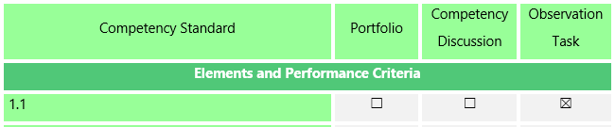
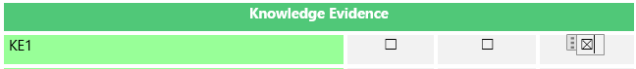

Competency Standard | Portfolio | Competency Discussion | Observation Task
Elements and Performance Criteria
1.1 | ☐ | ☐ | ☐
1.2 | ☐ | ☐ | ☐
1.3 | ☐ | ☐ | ☐
1.4 | ☐ | ☐ | ☐
2.1 | ☐ | ☐ | ☐
2.2 | ☐ | ☐ | ☐
2.3 | ☐ | ☐ | ☐
3.1 | ☐ | ☐ | ☐
3.2 | ☐ | ☐ | ☐
3.3 | ☐ | ☐ | ☐
4.1 | ☐ | ☐ | ☐
4.2 | ☐ | ☐ | ☐
4.3 | ☐ | ☐ | ☐
Performance Evidence
PE1 | ☐ | ☐ | ☐
PE2 | ☐ | ☐ | ☐
PE3 | ☐ | ☐ | ☐
PE4 | ☐ | ☐ | ☐
Knowledge Evidence
KE1 | ☐ | ☐ | ☒
KE2 | ☐ | ☐ | ☐
KE3 | ☐ | ☐ | ☐
KE4 | ☐ | ☐ | ☐
Foundation Skills
Learning | ☐ | ☐ | ☐
Reading | ☐ | ☐ | ☐
Oral Communication 1 | ☐ | ☐ | ☐
Oral Communication 2 | ☐ | ☐ | ☐
Numeracy 1 | ☐ | ☐ | ☐
Numeracy 2 | ☐ | ☐ | ☐
Navigate the world of work | ☐ | ☐ | ☐
Interact with others | ☐ | ☐ | ☐
Get the work done 1 | ☐ | ☐ | ☐
Get the work done 2 | ☐ | ☐ | ☐
Get the work done 3 | ☐ | ☐ | ☐
Assessment Conditions
tools, equipment and materials | ☐ | ☐ | ☐
studio and/or workshop facilities. | ☐ | ☐ | ☐
relevant information sources. | ☐ | ☐ | ☐
Dimensions of Competency
Task Skills | ☐ | ☐ | ☐
Task Management Skills | ☐ | ☐ | ☐
Contingency Management Skills | ☐ | ☐ | ☐
Job Role/Environment Skills | ☐ | ☐ | ☐

